Breathing in Bengaluru: Silent Killer on Wheels
Vivek V Gavimath

Public health is a fundamental pillar of society, with inextricable links to a country’s economic growth. For a service-, agriculture-, and manufacturing-driven economy like India with a population of over 140 crore, citizen welfare directly influences labour force participation and productivity.
Poor air quality has been widely recognised to have serious impacts on the public’s quality of life and economies worldwide, making air pollution a public health emergency. Road transportation currently contributes to 12% of carbon dioxide emissions in India and is a key source of urban air pollution. In the first article in this series, we take a closer look at vehicular exhaust emissions in India’s silicon valley, Bengaluru, and its impact on citizen health.
Bengaluru ranked 25th in the Swacch Vayu Survekshan 2023 rankings, accentuating the need for rigorous action to curb pollution. The Honourable Minister for Forest, Ecology & Environment, Government of Karnataka, expressed concerns about air pollution likely reaching Delhi levels. A study conducted in 2019 estimated about 80,000 deaths due to rising PM_{2.5} and PM₁₀ levels in Bengaluru. Further, recent studies have shown that 35% children in the city have asthma and 80% children aged below 5 years frequently experience wheezing.
The big chunk of pollutants
The IT capital of India, currently, has a population of about 1 crore, and over 80% households in the city own at least one motor vehicle. Consequently, the city has a large vehicle stock of over 57 lakhs. Vehicular emissions account for about 50% of particulate matter (PM) with a diameter of 10 micrometres or less (PM₁₀). Resuspension of dust due to vehicular traffic accounts for another 17% of PM₁₀ emissions (Figure 1). About 60% of nitrogen oxide (NO_{x}) emissions in the city are also attributed to vehicular traffic. With the population of the metropolis likely reaching 2 crores in 2030, the vehicle stock is correspondingly expected to cross 90 lakhs, further augmenting vehicular emissions.
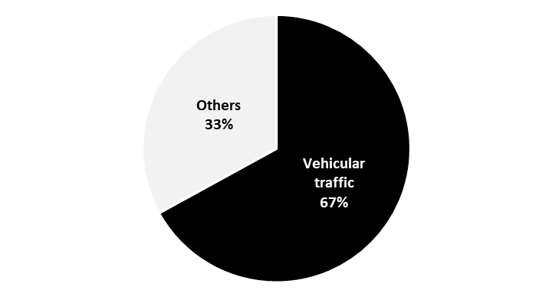
Figure 1. Sources of PM₁₀ emissions in Bengaluru

Impact of vehicular emissions on human health
Internal combustion engine (ICE) vehicles fuelled by petrol/diesel emit various harmful pollutants, including carbon monoxide (CO), hydrocarbons (HCs), NO_{x}, and sulphur oxides (SO_{x}) in addition to PM. Vehicular exhaust consists of trace metals and non-metals such as lead and sulphur. Depending on the duration of exposure (short- or long-term) to these pollutants, they may cause numerous diseases or health risks, such as respiratory infections; asthma; stroke; and tracheal, lung, and bronchial cancers. Table 1 lists common illnesses and the responsible pollutants in vehicular exhaust.
Table 1: Common illnesses and their causal pollutants
Illness/Disease | Responsible pollutants found in vehicle exhaust
Asthma and depletion in lung function | NO_{x}
Effect on liver, spleen, and blood | NO_{x}
Lung cancer | PM
Chronic obstructive pulmonary disease | PM
Impact on reproductive system | PM
Impact on central nervous system | PM
Headache and anxiety | SO_{x}
Eye, nose, and throat irritation | PM, NO_{x}
Breathing problems | PM, NO_{x}
Cardiovascular diseases | PM, SO_{x}
Source: European Environment Agency
Air pollutants, in general, and PM, in particular, have been categorised as the leading cause of cancer by the International Agency for Research on Cancer. The World Health Organisation (WHO) has shared evidence of the association between exposure to pollutants and obesity, diabetes, dementia, systemic inflammation, and Alzheimer disease. Further, children have under-developed and weaker immunity and organ systems compared with adults and are thus more vulnerable and susceptible to air pollution.
These grave dangers to human health highlight the need to reduce transport-related emissions/pollutants in the city to promote cleaner air. The next articles in this series will discuss the potential and challenges associated with various sustainable mobility measures like active mobility, integrated land-use planning, transit-oriented development, and other emerging systems like Electric Mobility as a Service (eMaaS) to reduce vehicular emissions in the metropolis.
The author works in the area of Green Mobility at the Center for Study of Science, Technology and Policy (CSTEP), a research-based think tank.

